Summary of pre-disaster literature review

Throughout our literature survey, we found several papers that were worthy of consideration for inclusion into the background and introduction section of our project. This will be a summary of those papers. In the end, we will discuss our proposed system for pre-disaster planning and readiness.

Before discussing the literature, a background of the usage of these drones is necessary. We plan to use these drones in the role of aiding first responders during a civilian evacuation. Evacuations are always chaotic and difficult to control, and any help offered to first responders and organizers will be crucial to evacuating and saving lives. First responder organizations like the police departments, fire battalions, paramedics, and dedicated evacuation response staff often have resources stretched thin and are inadequate when dealing with the sheer scale and unpredictability of disasters. Drones could serve in a variety of capacities to aid these first responders and our research intends to formulate new applications of drones in the field of evacuation response. One application that drones could serve in areas is communication drones or signal drones where they relay signals from organizers to evacuees in ways that normal signals cannot reach. The main application will be as pathfinders for evacuees and organizers. Drones can be used to search for safe evacuation paths before and during a disaster as UAVs, unmanned aerial vehicles, can get to and image places that humans cannot access.

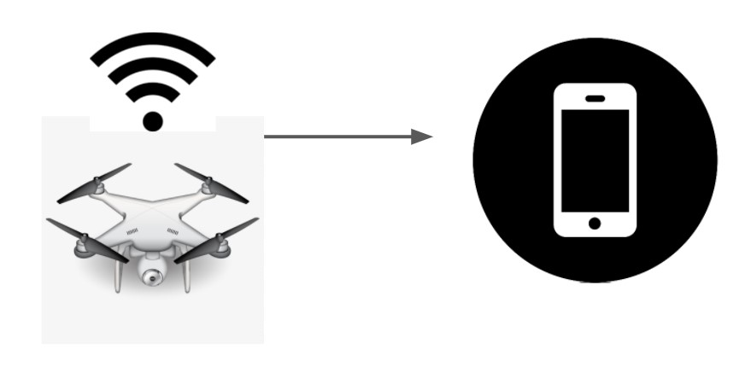

Some of the papers that we reviewed were concerned with the algorithm that the drones would deploy to do exactly that, search through an area for the best escape route. Obstacles can be pre-programmed or simulated for the drones and the drone must then identify a path considering all the simulated debris. This path can then be marked for later use if an actual disaster were to happen. During a disaster, drones can serve the same purpose. They can search through actual debris fields and disaster ruins and search for safe and easy paths that evacuees could use to escape an area and get to safety. Several algorithms were mentioned in these papers, including PSO (Particle Swarm Operation), WOA (Whale Optimization Algorithm). One paper was specifically about the testing of different algorithms and their computing cost and quality in determining a safe path through a field of obstacles. This experiment tests these searching algorithms, with different path-finding scenarios. Some include a few large obstacles while others include several smaller obstacles. It also runs scenarios where the path is clearly defined to a human but not as well defined to a machine. Each algorithm is used to find multiple paths and determine which path is the best based upon its travel cost and obstacle value. The algorithms are graded upon how good of a path it finds and how much computing power it needs to find that path. Through several such tests on all the algorithms across multiple different scenarios, the DGBCO (Dynamic Group Based Cooperative Optimization) algorithm proved to be the best searching algorithm because of its unique dynamic grouping capabilities.

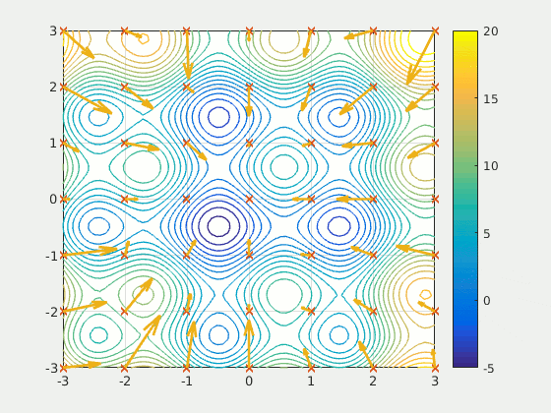

Another paper discusses the usage of big data resources to plan and analyze vehicle routes during an evacuation scenario. This paper's focus is wildfires, but the concepts can be transferable to other disasters as well. It states that there are two primary streams of traffic when a disaster occurs. One stream involves the evacuees, and the other stream involves the first responders. This is a common occurrence in all sorts of evacuations, from buildings on fire to entire city-wide evacuations. The paper also writes that this application was tested in a wildfire in British Columbia.

One paper dealt with a specific testing scenario as well as different applications for the usage of drones. This paper discusses the pre-disaster 3-D mapping of cities, specifically over the city of Victoria, British Columbia. This was the first mapping mission over an urban area approved by the Canadian aviation authority. The images were captured through sense Fly eBee Plus fixed-wing drone with real-time kinematic/post-processed functionality, with the goal being to assess the quality of pre-disaster data regarding geospatial accuracy of buildings and landmarks.

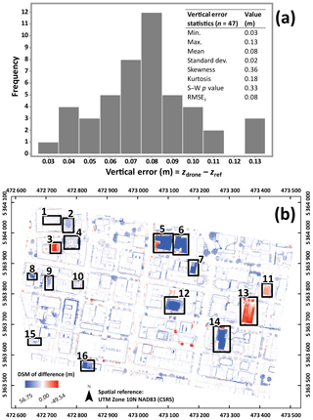

These papers are all useful in determining how a pre-disaster planning and path-finding system would work. Through our literature review, we have found that a combination of the DGBCO algorithm and a network of connected drones will be effective in tracking the movements of a group of evacuees, determining what paths they can take to escape the situation, and how best to allocate the resources that first responders and evacuation staff have available.

Citations

Agoston Restas (2015) Drone Applications for Supporting Disaster Management. *World Journal of Engineering and Technology*,**03**,316-321. doi: [10.4236/wjet.2015.33C047](http://dx.doi.org/10.4236/wjet.2015.33C047)

Z. Qadir, M. H. Zafar, S. K. R. Moosavi, K. Le and M. A. P. Mahmud, "Autonomous UAV path planning optimization using Metaheuristic approach for pre-disaster assessment," in IEEE Internet of Things Journal, doi: 10.1109/JIOT.2021.3137331.